

Guidance for Using Body Maps to Record Observations of Physical Injury

Where appropriate, **medical assistance should be sought without delay**.

**Body maps** are a tool to help staff accurately document and illustrate visible signs of harm or physical injury. They should be used in conjunction with the school's safeguarding recording procedures.

* Always use a **black ink pen** (not pencil), and **do not use correction fluid or erasers**.
* **Do not remove clothing** to examine injuries unless the area is already exposed due to treatment or the child’s clothing naturally allows visibility.
* **Staff must not take photographs** of any injuries or marks on a child’s body under any circumstances. Doing so may result in the staff member being subject to **managing allegations procedures**. Use the body map provided to record observations in line with this guidance.
* **All concerns must be reported and recorded immediately** to the appropriate safeguarding services, such as the **Multi-Agency Safeguarding Hub (MASH)** or the child’s allocated **social worker** if the case is already open to children’s social care.

When recording an injury, aim to include the following details for each mark observed (e.g. bruises, cuts, swelling, burns, scalds, lacerations):

* **Exact location** on the body (e.g. upper outer arm, left cheek)
* **Size** of the injury (in centimetres or inches)
* **Shape** of the injury (e.g. round, linear, irregular)
* **Colour** of the injury (note if multiple colours are present)
* Whether the **skin is broken**
* Presence of **swelling**, either at the site or elsewhere
* Any **scabbing, blistering, or bleeding**
* Whether the injury appears **clean or contaminated** (e.g. grit, fluff)
* Any **restriction in mobility** due to the injury
* Whether the site feels **warm to the touch**
* Whether the child appears **feverish or in pain**
* Any changes in the child’s **posture or body movement**

The **date and time** of the observation must be clearly recorded, along with the **name and role** of the person completing the record. Additional comments may be added where relevant.

If **First Aid** is administered, this should be recorded appropriately.

A completed body map should be stored securely within the child’s **child protection file**.

|  |  |  |
| --- | --- | --- |
| Names for child: |  | Details of physical injury: |
| Date of Birth: |  |
| Name of worker: |  |
| Signature of worker: |  |
| Name of school/college: |  |
| Date and time of observation: |  |

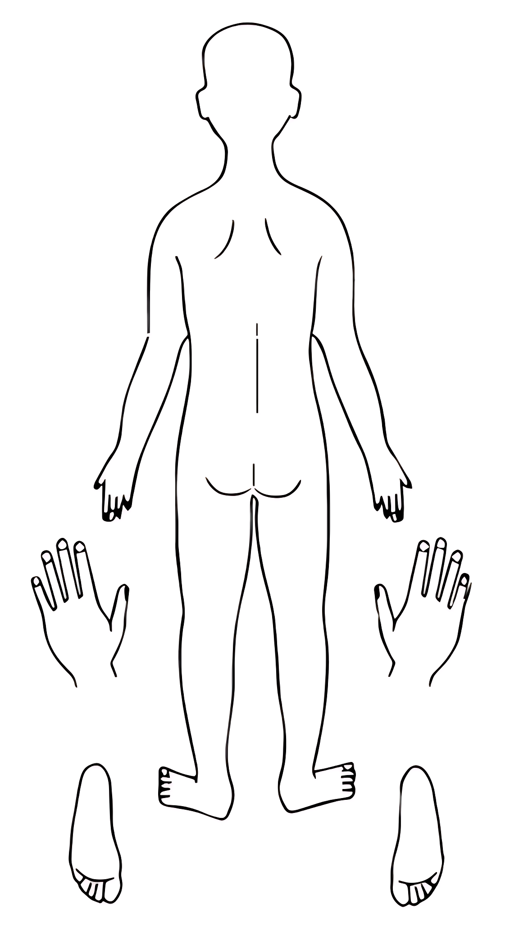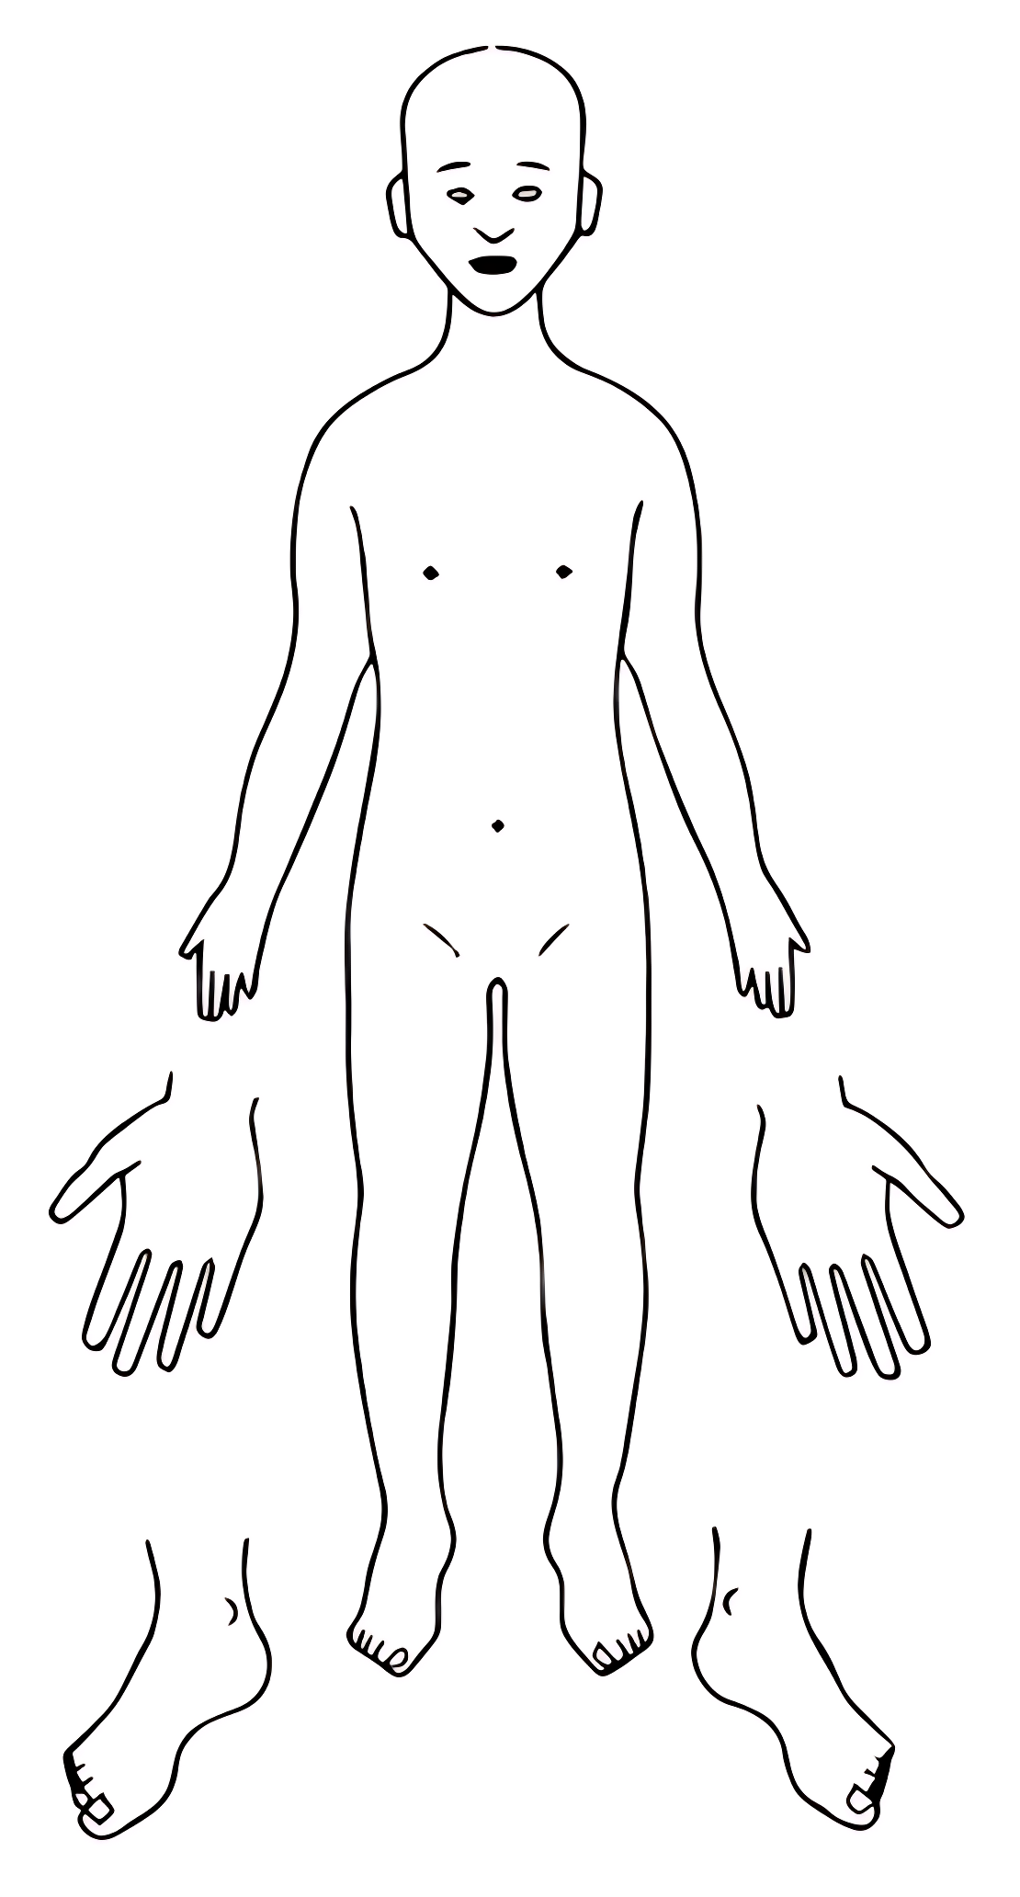

**BACK**

**FRONT**

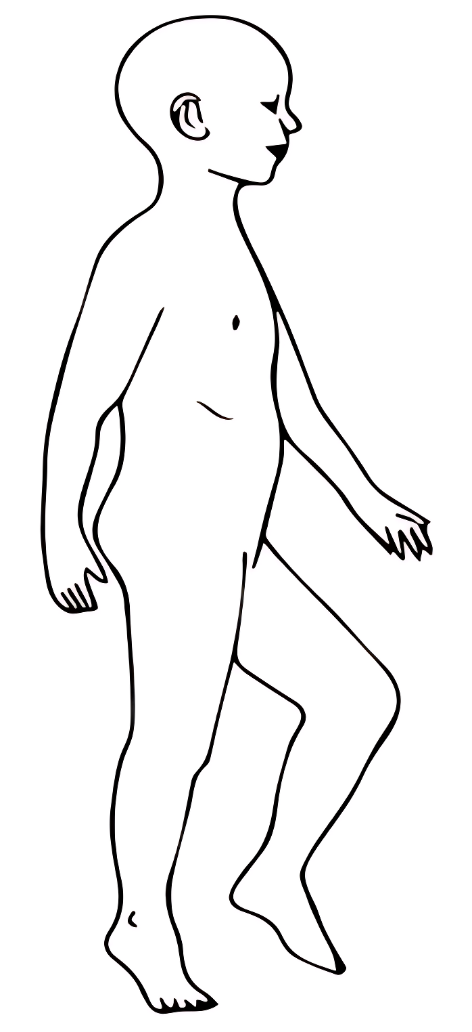

**LEFT**

**RIGHT**

|  |  |  |
| --- | --- | --- |
| Names for child: |  | Details of physical injury: |
| Date of Birth: |  |
| Name of worker: |  |
| Signature of worker: |  |
| Name of school/college: |  |
| Date and time of observation: |  |

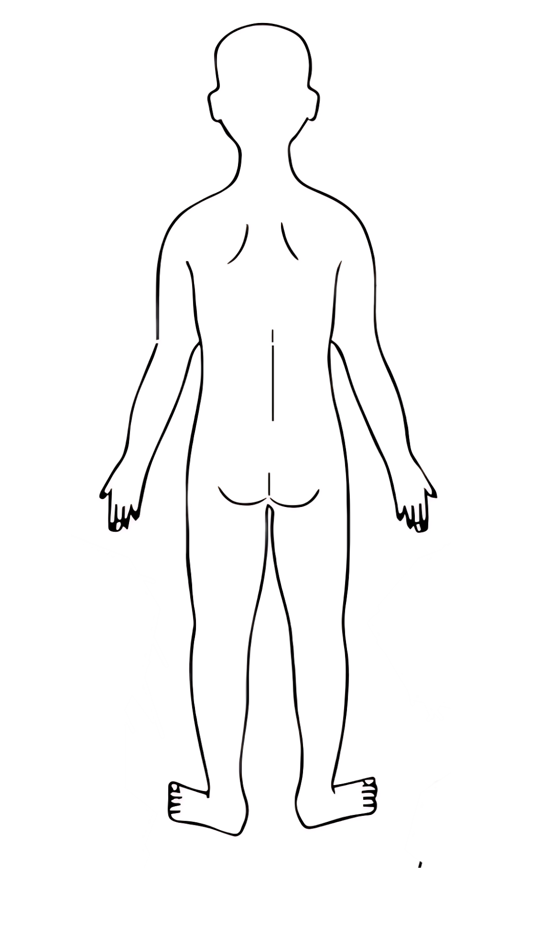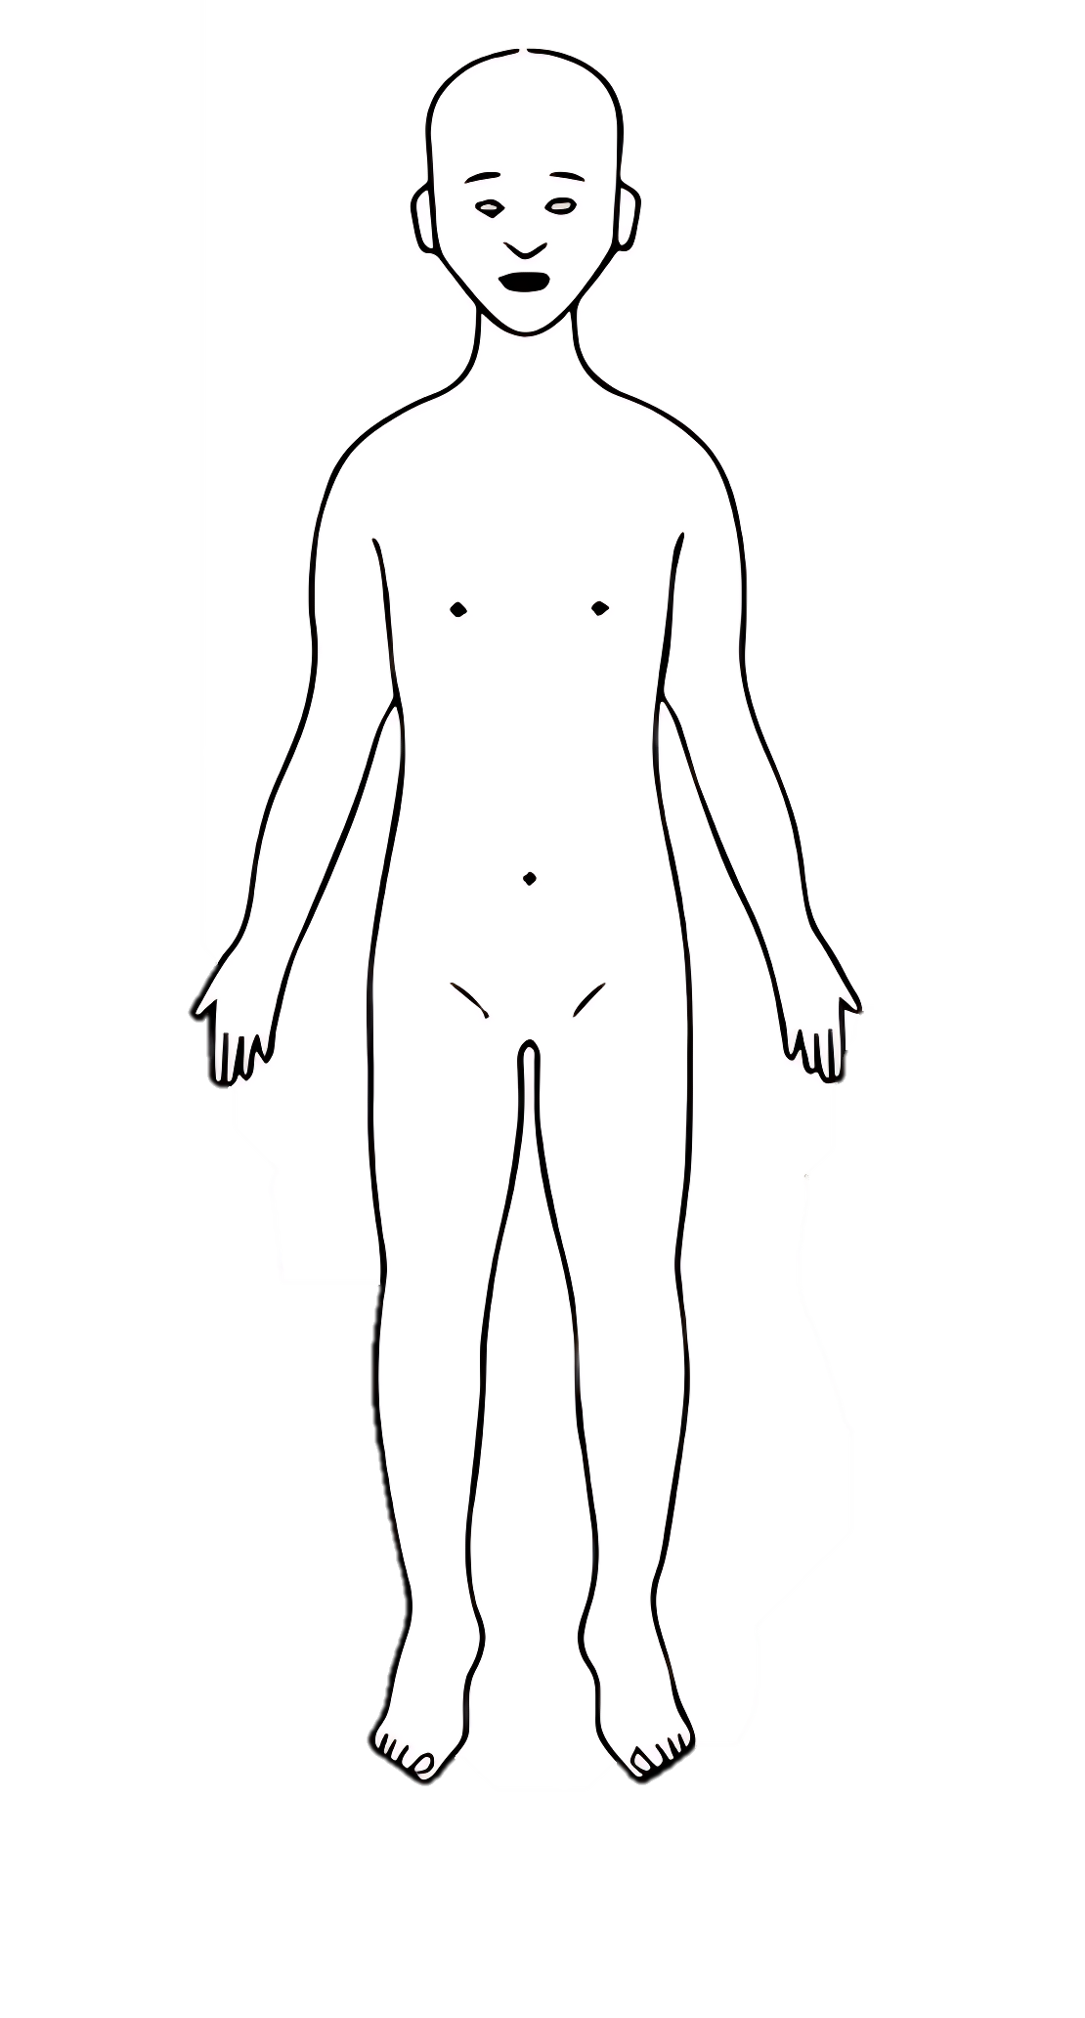

**BACK**

**FRONT**

|  |  |  |
| --- | --- | --- |
| Names for child: |  | Details of physical injury: |
| Date of Birth: |  |
| Name of worker: |  |
| Signature of worker: |  |
| Name of school/college: |  |
| Date and time of observation: |  |

**RIGHT**

**LEFT**

|  |  |  |
| --- | --- | --- |
| Names for child: |  | Details of physical injury: |
| Date of Birth: |  |
| Name of worker: |  |
| Signature of worker: |  |
| Name of school/college: |  |
| Date and time of observation: |  |

**BACK OF HANDS**

**LEFT**

**RIGHT**

**PALMS**

**RIGHT**

**LEFT**

|  |  |  |
| --- | --- | --- |
| Names for child: |  | Details of physical injury: |
| Date of Birth: |  |
| Name of worker: |  |
| Signature of worker: |  |
| Name of school/college: |  |
| Date and time of observation: |  |

**RIGHT**

**LEFT**

**BOTTOM OF FEET**

**TOP OF FEET**

**LEFT**

**RIGHT**