NSCP Record of completed Learning

Click on My Learning (blue box on front screen) then:

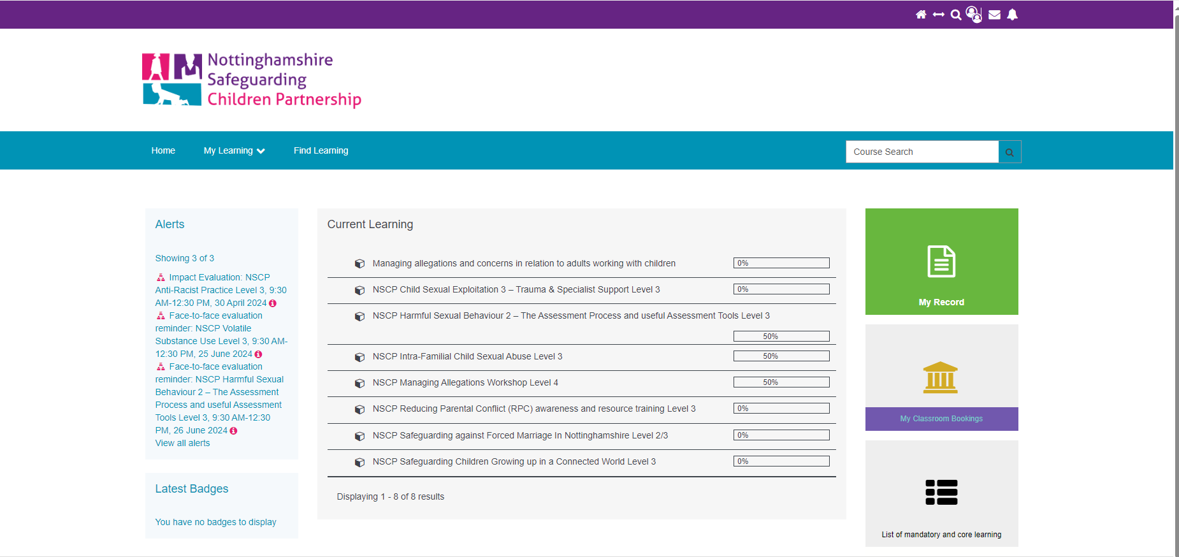

Click on green box

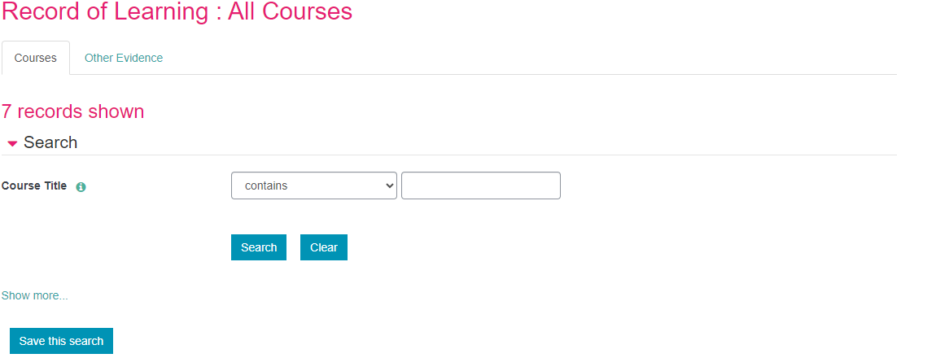

Click on show more

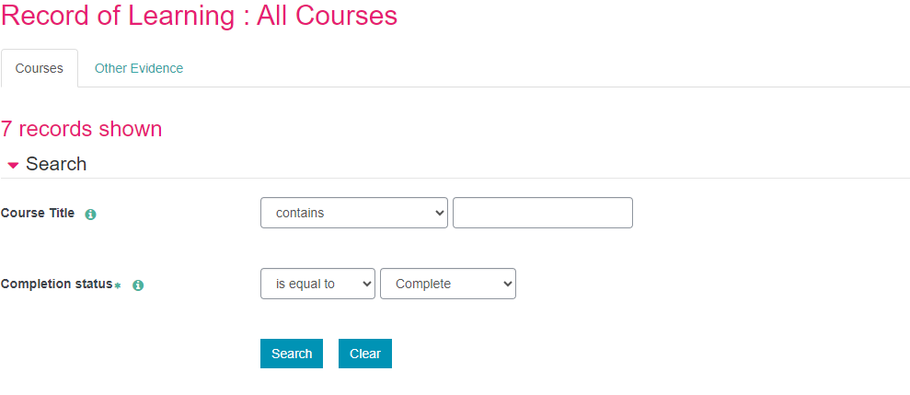

Click on dropdown boxes to show is equal to and complete. Click search.

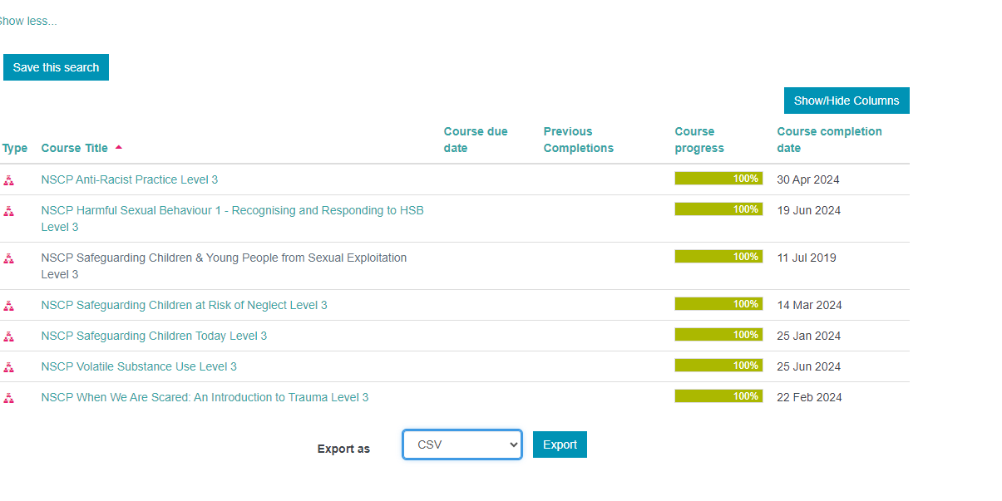

Change drop down option to excel and then click on export

The report will be saved in your download folder.